
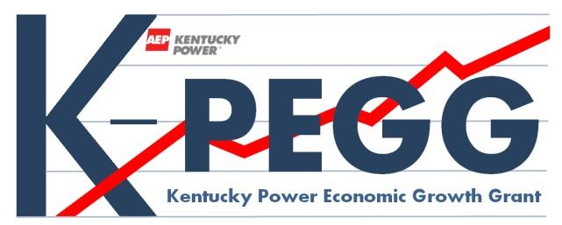

GRANT REQUEST NO.

Kentucky Power Economic Growth Grant
K-PEGG Fund
GRANT APPLICATION

Applicant:

Primary Contact:

Phone: | Fax: | E-Mail:

Alternate Contact:

Phone: | Fax: | E-Mail:

Address:
Community: |  | State: | Zip:

Project Location:
(Describe KY Power service territory that will benefit)

Funding Request ($):
Are you a previous grant recipient?
Previous recipients are required to complete the reporting requirement prior to application submission.

Explanation of Project or Organizational Need:

Project or Organizational Scope (Area/Region):

Anticipated Results:
Number of Jobs to be Created within 3 years:
Number of Existing Jobs to be Retained within 3 years:
Describe Anticipated Results of Proposed Project:
Other Pertinent Information:

Explain the Project Budget, including use of Kentucky Power K-PEGG Funds:

Additional Information to Lend Support to this Request:

List other Partner Organizations and Collaborators with Contact Information:

Estimated Project Schedule (if applicable):
Project Start :
Project Completion:

Applications must meet program guidelines and receive final approval from KY Power

KY Power K-PEGG Fund Recommendation (KY Power use only) | $

Applicant Type Name and Title
Date:

KY Power Representative Name and Title
Date:

- All K-PEGG applications must be submitted electronically in the provided format to kpegg@aep.com. Please scan supporting documentation and cover letter and include with your application.

- The K-PEGG program will not have any deadlines for request. The program is designed to be flexible in an effort to meet any potential economic development needs year round, as deemed qualified by the K-PEGG review team. A request can be made at any time by completing this request form and by providing any necessary supplemental information.
- Incomplete applications will not be returned for revision.

- Requests for Kentucky Power K-PEGG funds must meet specific program requirements. The total planned giving for all awarded projects for any given year will not exceed the amount collected and matched through the Kentucky Economic Development Surcharge (KEDS), this will be approximately $720,000 annually. Kentucky Power reserves the right to adjust potential grant awards based on competitive requests, appropriateness of requests, fund availability, and other criteria established by Kentucky Power.

